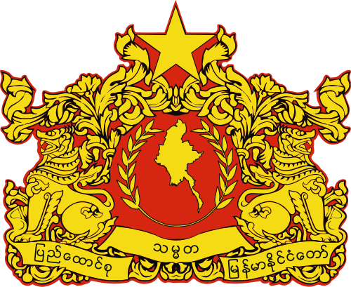
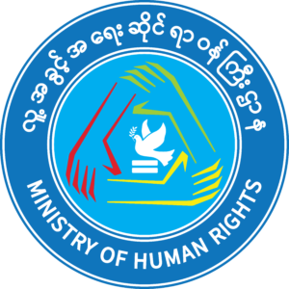
Republic of the Union of Myanmar
National Unity Government
Ministry of Human Rights

Statement on International Day of the Victims of Enforced Disappearances

Date: 27 August 2021

1. August 30th marks the Statement on International Day of the Victims of Enforced Disappearances. Enforced disappearance means arrest without the will of a person or group of people by a government or an organization or someone represented of it denying their rights.

2. It can be found that people included in enforced of disappearance in many countries’ history. Dictator governments tend to intentionally arrest or make human rights defenders, their families and human rights violation documents disappear.

3. Enforced disappearance effects not only on the individuals, each families but also on the justice system. Making a person disappear without his/her will is a human rights violation and it affects the right to life, security and development of every citizen in a country. Because of unfair arrest and elimination, it causes sorrow and social, economic impacts on family levels. Likewise, as there is no access to legal rights according to the law, not being able to prosecute those responsible, it can lead to the culture of impunity.

4. It is very important that the data collection and archiving process for human rights violations, those who had to suffer the crimes of the military junta not only during the Myanmar spring revolution as well as in the ethnic areas since many years ago. Ministry of Human Rights will work together with international organizations, civil society organizations and people to prevent such events from happening again, to bring out the truth, and to heal the sufferings of each of those who disappeared, fallen based on those records.

5. Memory of the people is the characteristic of the people that the dictators despise of. Preserving, archiving and handling of their human rights violations that the dictators want to be forgotten is participating in the revolution. it is very important step to be making for justice by preserving as much as possible of the history, events, stories and memories of revolution comrades made disappear by the junta. We shall not forget the values they held and continue our fight for human rights and equality.
Ministry of Human Rights
National Unity Government

